Subtask 5
Sorting Criteria and …
RSD1– Robot System Design

Group members:
1. Audrius Palisaitis
2. Kalle Grafstrom
3. Martin Moghadam
4. Robertas Jacauskas

2010-06-02

Content

- Introduction
  - Project description
  - Entire system structure

- Review of possible systems

Washing machines facilities are use from traditional to the industrial. Main differences of those two areas are water usage, clothes amount and etc.

Advantages / disadvantages of
Commercial |  | Non-Commercial
Hotels, restaurants, hospitals, elder homes and etc. |  | Living houses, rooms, dormitories and etc.
Advantages | Disadvantages | Advantages | Disadvantages
High efficiency.  Usage of the water can be decreased.  (High amounts of clothes can be washed more efficiency than small amounts. For instance during one wash, washing machine utilizes the same amount of water. Higher amounts of clothes can be more optimally to wash then small. | Delays. (1. Maybe sometimes need to wait while laundry room wash your clothe. 2. Person needs move from home to laundry room wash his clothes. Both situations uses person time) | Cheaper, faster.  (Sometimes faster to wash at home than to move somewhere in the city) | High usage of water.  (Usage of the water is not optimal: During one wash not always possible find the max amount of clothes. )

- Project management

  - Project goals
- Create, configure, manage and provide access to data base
- Create general library which is able manage information in the data base.
- Create socket transfer server for communication purposes
- Create sorting algorithm
- Manage RFID reader
- Connect and control all software parts together

  - Project resources

During project development stages were used hardware and software resources described bellow.

Hardware resources:
- Configured MySQL server with internet access or access on SDU domain
- Working RFID readers

Software resources:
- MySQL data base
- Microsoft Visual C# tool
- .NET framework 3.5
- MySQL Connector Net 1.0.10
- Created simplified remote data base configurator

  - Project planning

Project duration is approximately 19 weeks, for designing and implementing software. To make sure that everything will be on the schedule were made gant chart table 3.1. Here described tasks and it have to be done in marked weeks. Project starts on February 3 and finish at June 9 day.

Table 3.1: work flow (gant chart)
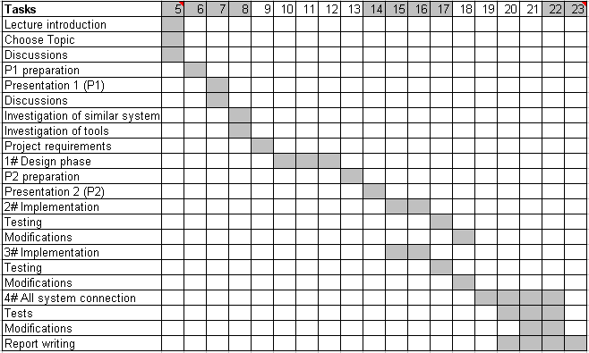

Work flow divided into four phases:
- 1# Design – drawing diagrams, talking about similar systems and tools
  - Entity relation (ER) diagram
  - Data base connection class diagram (MySQL library)
  - Sorting algorithm diagram
  - Socket transfer protocol specifications
- 2# Implementation
  - Configuration of data base server
  - Implementation of MySQL libraries
  - Configuration of Web server
  - Sorting algorithm
- 3# Implementation
  - Socket transfer server
  - Sorting algorithm
- 4# All system connection – all part connection into one software
  - Control RFID reader and provide access to subtask 4
  - Connect RFID reader with sorting algorithm
  - Connect RFID reader with socket transfer server
  - Connect all together: RFID reader, MySQL library, socket transfer server and sorting algorithm
  - Work responsibilities

Table 3.2: work flow responsibilities
Responsibilities | Tasks
All | Lecture introduction
All | Choose Topic
All | Discussions
All | P1 preparation
All | Presentation 1 (P1)
All | Discussions
All | Investigation of similar system
All | Investigation of tools
All | Project requirements
All | 1# Design phase
All | P2 preparation
All | Presentation 2 (P2)
All | 2# Implementation
All | Testing
All | Modifications
All | 3# Implementation
All | Testing
All | Modifications
All | 4# All system connection
All | Tests
All | Modifications
All | Report writing

  - Expectations

To make sure that project will be delivered in time and all software function.

- Collaboration between subtasks

Successful project requires close collaboration between subtasks. Each subtask has own knowledge area, requirements and expectations, however subtasks are closely related. In our case we are totally software part and we work on that, however something we need from other groups. Bellow shown

  - Collaboration between subtask 4 and 5
    - Requirements from task 4
      - Provide list of scanned clothes throw defined protocol [Appendix A].
    - Requirements to task 4
      - No requirements.

  - Collaboration between subtask 6 and 5
    - Requirements from sub task 6
      - provide access to data base throw created library
    - Requirements to task 6
      - Provide library of RFID readers

  - Collaboration between subtask 2 and 5
    - Requirements from sub task 2
      - Allocate data base space to store data.
      - Created tables
      - Provided general libraries
      - Provided configuration tool

During the project were a lot of meetings between groups and their let understand real project flow and complexity. Meetings and discussions were important and let understand what is wrong and what is going well. Without meetings and discussions be difficult to work and finish project in time.

- Data Base design

Around the world there are a lot of different types of data bases [1]. However we used mySQL most popular – relational data base. Relational data bases are easily understand [2] and use. In general relational data bases – collection of relations and also it fit all our requirements.

  - Why MySQL?

Amount of different relational data bases are huge [3] and sometimes are difficult to choose. Our choice was MySQL data base, because it is:
- Open source data base
- Ease to use
- Fast performance
- Reliable
- Most popular open source DB in the world
- It use Yahoo!, Alcatel-Lucent, Google, Nokia, YouTube and others

  - ER diagram

Design of the data base mostly starts from modeling data base. One of the most popular approaches is conceptual modeling by using entity relational diagram (ER) [4]. Entity relational diagram shows collections of relations in modeling database. ER diagram allow easily understand concept of the data base. Another methodology to model data base can be used UML diagram. Most of the OOP programmers are familiar to UML and it make so popular. In our design we used ER diagram and later it were converted to UML [Appendix B].
Person
Clothes
Fabric
Color
DryRecipe
State
WashingTemperature
CPR
BinId
Has
Has
N
M
Weight
Name
Has
Name
Surname
middleName
CPRNo
1
1
PictureURL
Address
Has
Type
1
1
City
RoomNo
BuildingNo
Street
CPRNo
PostCode
Country
CPRNo
Id
Tags
Id
Year
Month
Day
WashCount
CPRno
1
1
Figure 5.1: Laundry ER diagram

  - Implementation

Make data base to work we need create tables and move them into data base. Data base tables were created by using query language like shown in the figure 5.1. All the code was written into text file and text file uploaded directly to data base by using created configurator tool.

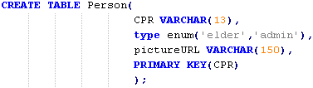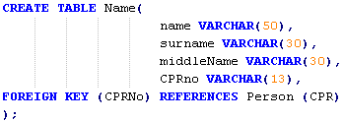
Figure 5.1: Person and Name tables

Table person have three attributes: CPR, type and pictureURL and primary key for CPR. Primary key makes table to be unique, without a key table become weak entity type, note that always is good to have tables of strong entity types [4]. Foreign key makes table name also unique. In other words table name have one unique reference to table person and table person is unique.
Make easy for data base management were created data base configurator, which is able connect to data base and configure by query language or send files with configuration sentences. This manner let faster update and change without writing.

  - Future work

//Usage of all tables is not optimal and some attributes do not used at all so space usage can be decreased.
//Speed increased

- Laundry data base library

Mostly of the project subtasks decided to use one programming language to make easy work together. Sometimes different languages can be difficult connect and work together. That is why decided to use one object oriented language – C#. As we know C# is a new generation language which provides a lot of advance features like garbage collector and more others. This kind of language makes easier developer write programs, because here do not need take care about low level features like memory allocation or lost pointer. So this kind of language can decrease development process and increase code efficiency.
Our case design was to store and provide data about the elders. All data were stored in MySQL data base. So many of subtask would like to use it and that is why were decided to create general library for any to use. Main design requirement is to create general library which has features: reliable, easy maintain, simple to use, and easy update.

  - Design phase

To keep above mentioned requirement and features, decided to create a DLL (dynamic link library) which can be executable and contain inside code, data, and resources. Our design library inside have two classes:
- MySQLConnection – data base connector which responsible for connection to data base and send/receive queries.
- Functions – general library for laundry data base.

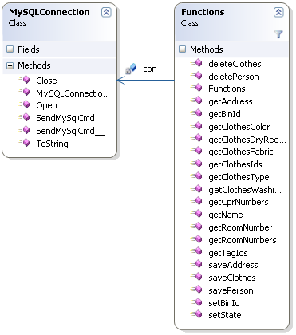
Figure 6.1: Class library of the data base connection

  - Implementation

Software development was related to unified process (UP) – iterative incremental process. Iterative incremental process model [5] was used during the implementation.
Let us explain everything in more detail. Project were created using class Library in Microsoft Visual C# .NET 3.5. To have data base connection were included MySQL Connector Net 1.0.10 into references. To use created library we need include it into new project (Console or Win or else) and start our library. For example we insert our library into console project, so connection to data base is like shown in the figure 6.1. After successful connection we can use class functions and manage laundry data base.
Numbers explain data base connection parameters:
- IP address or domain:
- Data base name
- User Id
- Port number
- Password

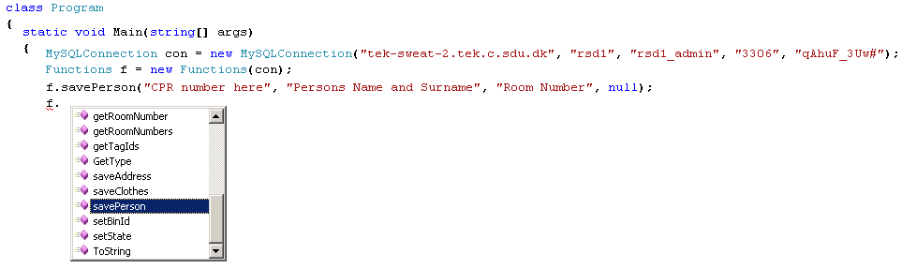
1
2
3
4
1
Figure 6.1: Connection to data base server and save new person

Class functions uses created instance of MySQLConnection library. And throw the variable f can be connected to all created methods. At the figure 6.2 shows an example of creation new person. As we can see there used methods send queries to data base. New CPR inserted into table person by query: “INSERT INTO Person (CPR) Values (‘1234567890’)”.

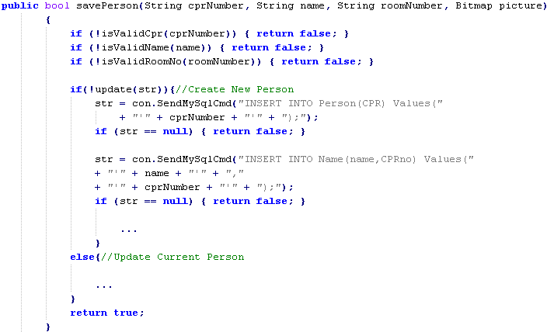
Figure 6.2: Example of save person method

  - Future work

- Socket transfer server

Another more general approach is to use socket communication [6] protocol. Many applications – from the networks to the mobile phones [7] use sockets. Designing software requirement is communicate with the clients and provide data base information. Also keep multiple connections at the time and keep it simple. Socket transfer server also like MySQLLIbrary was designed by using C# programming language. It is reasonable to use one programming language during all project, therefore connection to other part be easier.

In general sockets very usable to use:
- Created socket transfer server and specified protocol can be used and understand by any programming language.
- Easy update and maintain – new requirements only updates protocol specification, does not need to change server.

  - Socket protocol specification

To start design and implement our software we need to define protocol. Throw the protocol we communicate and change information. General protocol description showed in the table 7.1. Start command defines protocol type and always communication string start with 0xFE. Command type range allocated from 0x11 to 0x90, where is one byte describing command. The last one is value where is a content of data.

Table 7.1: General protocol specification
Start Command [0xFE] | Command type [0x11 – 0x90] | Value
1 byte | 1 byte | 4 or 24 bytes

Example 7.1: Subtask 4 wants to get a bin number for particular tag. So they sending string like this:
“0xFE 0x12 0x30 0x30 0x30 0x30 0x31 0x32 0x33 0x34 0x31 0x32 0x33 0x34 0x41 0x41 0x31 0x32 0x33 0x34 0x35 0x36 0x41 0x34 0x35 0x36”, where at the beginning defined protocol type and command type, rest of the hexadecimal values are tag id. If there are no errors in the string transfer server converts tag id to ASCII characters and sends constructed query to data base. Response from data base will be ASCII character which will be converted to hexadecimal and constructed packet send back to the client: “0xFE 0x12 0x00 0x00 0x00 0x00”.

Table 7.2: Command packet (from client to server)
 | Protocol type | Command type | Value
Value | 0xFE | 0x12 | 000012341234AA123456A456
Bytes | 1 | 1 | 24

Table 7.3: Command packet (from server to client)
 | Protocol type | Command type | Value
Value | 0xFE | 0x12 | 0
Bytes | 1 | 1 | 4

  - Design and Implementation

When protocol specified we can start design and implement software. Class diagram shown in the figure 7.1. Here we can see four part:
- Starts server and stops main thread forever.
- Started server waiting for incomming packets. Incomming socket packet rises event.
- Transfered protocol opened and checked for incoming command. If command is not recognized then execution stoped and waiting for another incomming packet.
- Socket packet is class where defined buffer size, incoming client information.

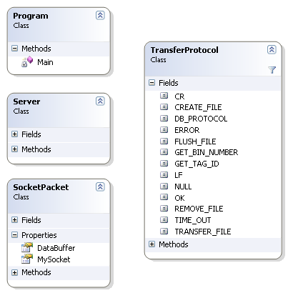
Figure 7.1: Class diagram of the socket transfer serer

  - Future Work

In the future socket transfer server can be extended to have files transferring features and some security. File transferring protocol already defined however do not implemented. It could be used save elder picture. Security could be used to make safe transfer. However both of above mentioned features are not important. Picture is just additional feature and does not make sense to project. Security only necessary if transferring server will be placed out of the domain. In other case local LAN is already have security.

- Sorting algorithms

All of us know that washing black and white together is a bad idea; however there are a lot of criteria to distinguish and prepare clothes for washing. This chapter presents several sorting algorithms for preparation to wash.

  - Requirements / criteria’s

Mostly all of the clothes have the sewed label (tag). There are defined information about fabric, washing temperature and etc. For instance fabric defines the material of clothe –how clothe is sensitive. For instance wool is more sensitive when synthetic or clothe which can be washed 40 degree is more sensitive than clothe which can be washed 95 degree. Of course sometimes 40 degree clothe can be washed on 30 or 60 degree and 95 degree can be washed on 60 degree temperature.

A general criterion’s used to create sorting algorithm:
    - Colour – often there are bad idea wash white and black together, so this criteria defines that clothes of colored and white should be distinguished and washed separately.
    - Washing temperature – some clothes are more sensitive than other, so clothe should be washed on temperature defined by label in other case there could be possibility to damage clothe.
    - Fabric – defines material of the clothes. For instance wool, cotton, synthetic and etc. All those material types have different sensitive criterions. Comparing wool and synthetic of the same color and temperature we should take in to account that wool is higher priority clothe and same synthetic clothe should be washed regarding rules of wool.
    - Weight – defines bin size of washing machine size. In other words how many clothes can fit to washing machine and be washed.

Abstract criterion defines how clothes can be washed:
- White and light clothes can be washed together
- Colored and dark clothes can be washed together
- Light, white and cotton often are washed on higher temperatures 60 degree or higher
- Cotton and wool can be washed together, however all rules set regarding wool
- Daily clothes temperatures around 60 degree
- Work clothes temperatures around 90 degree
- Washing temperature of wool is low (below 40 degree)
- Cotton more sensitive than synthetic
- Wool more sensitive than cotton

  - Sorting algorithm designs

    - Sorting by color and temperature

Algorithm presented in figure 8.1 is one of the simplest, which is also implemented. When list of clothes comes to sort, then each clothe are moved to particular bin. First are sorted by color and then by temperature. Number of total possible bins is ten – five for colored and five for white. Bins are numbered automatically.

List of clothes

Colored
White
HW
30˚
40˚
60˚
95˚
HW
30˚
40˚
60˚
95˚
Figure 8.1: Sorting algorithm by color and temperature
This kind of algorithm is not optimal, because one clothe can be washed as well. Of course if time is not so important, then clothes from the bin should be washed when bin is full.
    - Sorting algorithm using configurable parameters

A lot of laundry institution sorting clothes similar but not the same. One of them has different size washing machines others wash at the higher temperature and all of them have distinct criteria’s. So question is: how can be created software which satisfied all user requirements.
Here presented software based on C# language, software consists of two parts: configuration and sorting algorithm. Configuration part is finished, however sorting algorithm do not finished. Purpose of the configuration is to save and load sorting criteria’s created by user.
Each of clothe has sewed label which defines temperature, fabric and it would be great to prioritize clothes by sensitive. Purpose of that is to sort by priorities; more sensitive clothes have more privileges than low priority clothes. Same color and same washing temperature clothes could have different priorities, for instance one clothe is from wool and another from synthetic, so synthetic (possible) is lower priority than wool and should be washed considering wool. Clothes of the lower priority washed considering higher priority and highest priority washed like it have to be washed. Figure 8.1 (left) presents an example of configured priorities. Most significant clothes are in the top of list (example: Cotton: Hand wash: 95, Wool: Degree 30: 90) and have the highest priority and least significant down in the list.
Different institutions have different washing machine sizes, and all of them during one washing cycle want to utilize max clothes. That is why included parameters like total washing machine size and each clothe size figure 8.1 (right). Total washing machine size defines the threshold (in that case 87%) which defines when is not optimal to wash. In other words washing machine utilization bellow 87% is not optimal and can not be washed. Another configuration of size is how many units of particular type of clothe can fit in one washing machine. For instance in one washing machine can fit 30 shorts (Shorts: 30), so size of the shorts is approximately 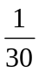 or utilization of washing machine is about 3.33 %. So min size of same units can be: 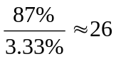

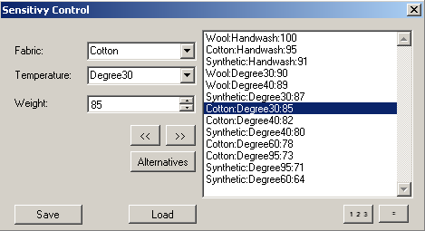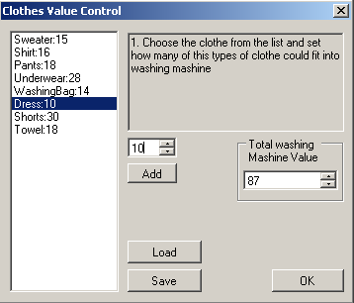
Figure 8.1: Left: clothes sensitive control; Right: clothes value control

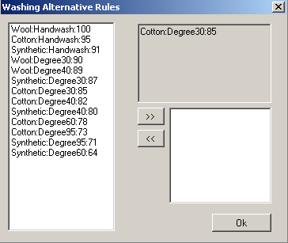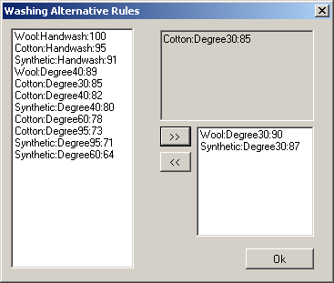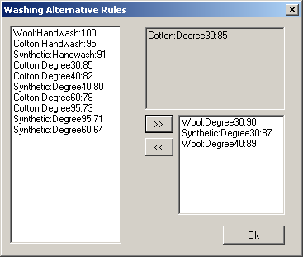
Figure 8.2: Washing alternative rules

Last feature included is washing alternatives, in other words what to do then clothe can not be washed in particular case. Figure 8.2 presents alternatives of cotton: 30 degree. As we can see this kind of clothe can be washed with the wool: 30 degree (plan B) or Synthetic: 30 degree (plan C) or wool: 40 degree (worst plan if before two does not fit). Each clothes could have any size of plans. All above mentioned parameters can be saved, loaded or updated for the next time use. As we can see many features provides quite wide range of washing possibilities.

Further presented sorting algorithm which shown in the figure 8.3. There are four parts (Init, I, II, III) describing algorithm in more abstract level. There is one input for incoming clothes and three outputs for outgoing results of the sort. Incoming clothes have parameters like: color, washing temperature, clothe type and fabric and result is a bin designated to current clothe. Let us explain those four parts in more detail:
    - Init – all incoming clothes sorted by color and washing temperature. By default all clothes get bin ids and calculated current state. Current state – defines is sort is enough efficiency.
    - I – check for success. That part check is current state enough efficiency. If it is than algorithm stops, or emerge time out.
    - II – try to move clothes from rest to reserve using washing alternative rules.
    - III – try to decrease number of clothes. For example at the table 8.1 rows two and nine utilization is the same 818%, however efficiency is different. One uses 8 bins and not efficiency another pass then uses 9 bins (times to be washed).

Init
II
III
I
I
Figure 8.3: Sorting algorithm

Loop is going I, II, I, III, I... while do not get efficiency greater than 87% (like set in configuration). By default if there are no configurations set, then algorithm works like presented in above chapter (sorting by color and temperature).

Table 8.1: Example of current state (when: Total washing machine value 87 %)
Bin Id | Color | Washing  Temperature | Total Bin  Utilization  (TBU) | Number of bins Require  (NBR) | Rest | Efficiency | Reserve | Success
1 | White | 95 | 448 % | 4 | 48 % | 48 % | 52 % | Fail
2 | White | 60 | 818 % | 8 | 18 % | 18 % | 82 % | Fail
3 | White | 40 | 89 % | 1 | 0 % | 89 % | 11 % | Pass
4 | White | 30 | 639 % | 6 | 39 % | 39 % | 61 % | Fail
5 | White | HW | 159 % | - | - | - | - | -
6 | Colored | 95 | 698 % | 7 | 0 % | 99 % | 2 % | Pass
7 | Colored | 60 | 2110 % | 21 | 10 % | 10 % | 90 % | Fail
8 | Colored | 40 | 788 % | 8 | 0 % | 98.5 | 1.5 % | Pass
9 | Colored | 30 | 818 % | 9 | 0 % | 90.8 % | 9.2 % | Pass
10 | Colored | HW | 420 % | - | - | - | - | -
11 | … | … | … | … | … | … | … | …
- | - | - | - | - | - | Total: 62.54% | - | All: No

Current state of the sorting is respresented by table where all values mutate during sort. Quantity of incomming clothes set bin ids and total bin utilization (TBU). TBU – how many times need to be washed it calculated by 8.1 formula:

(8.1)

Where clothe type can be: Sweater, Shirt, Pants, Underwear, WashingBag, Dress, Shorts, Towel and BedLinen.

Clothes coefficients: 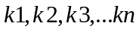 set by clothes value control.
Calculation of how many number of bins require (NBR) done by 8.2 formula:

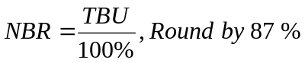 (8.2)

Rest calculated by 8.3 formula: 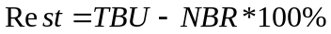 (8.3 ), if reusult negative than is no rest else rest.
Rest means how many percent of clothes left and can not be washed, because of to small amount. So rest can be zero or lesser than 87 %, because 87% indicates smaller entity which can be washed.
Efficiency can be calculated considering rest, diagram shown in figure 8.4. Efficiency describes is there cost-efficiency to wash or not. Wash is cost efficient than efficiency is greater 87%.
Efficiency = Rest
Rest == 0
Rest != 0
Efficiency = TBU / NBR

Figure 8.4: Efficiency calculation diagram

At the beginning incoming clothes are toke one after another and moved to the particular bin. If there are no clothes left than check how many distinct bins require. If there are more than zero bins than calculated and set current state like shown in the 8.1 table. If there are no clothes therefore there are no bins and algorithm is ended.
Bins == 0
Take clothe and move to bin
Remove clothe from list
There are clothes
Bins > 0
Set current state
Figure 8.5: Diagram Init
Second move of algorithm is check for success and for time-out, figure 8.6. If all bins are greater efficiency than 87% than current state is satisfied and clothes can be washed. In other case there is time-out algorithm also stopped. Purpose of the time-out added to avoid infinitive loop.
All Success
Check for Time-Out
Time-Out
Check for Success
Figure 8.6: Diagram I

Last two moves are very similar. Both of them try something to change when estimate current state and compare with previous. If new state is better than previous then state is set to current, in other case keep the last state.
1. Take Bin which has Rest.
2. Try move clothes from current Bin to Bins which have reserve
Calculate current state
Check is new state better than last
Set current state
Set last state
Better
Worse
No || Time-out
Yes
Check is there are bins which has rests
||
Check Time-Out
Figure 8.6: Diagram II

At the figure 8.6 sorting algorithm trying to change the current state by moving clothes from bins which have rests to bins which have reserves and if result is better then new state set to current.
Set current state
Set last state
Check is there are bins which has rests
||
Check Time-Out
Try decrease number of clothes in particular type of Bin to get higher efficiency
Calculate current state
Check is new state better than last
Better: total efficiency increased
Worse: Total efficiency decreased
Yes
No || Time-out
Figure 8.7: Diagram III

At the figure 8.7 sorting algorithm trying to change number of clothes in particular type of bin. For instance quantity of 818% gives result for 8 bins and 18% rest. However efficiency of 8 bins is 100% and for the last one is only 18%. Eight bins can be washed however the rest should be wait. So if there will be decreased number of clothes during one wash then could be increased efficiency. If 818% of clothes we wash by 9 bins then we get efficiency of 90.8% and reserve 9.2%. So this is optimal and new state is set.

As we can see there are concurrency between II and III. If something changed at II then III have also possibilities to change and vice versa. Concurrency is essential to get a progress and mutation of states.

- Entire System Integration

To make sure that all parts work, need connect them all to one software mechanism or control flow goes throw one point. Other case design could be multi agent systems (MAS) where all software will be separate agent.

Sorting algorithm, RFID reader, MySQL Library, socket transfer server

RFID Reader
MySQL Library
Sorting Algorithm
Socket
Transfer Server

  - Tests/Analysis/Functionality

Table 9.1: Estimation in percents of current system
No |  | Audrius Palisaitis | Kalle Grafstrom | Martin Moghadam | Robertas Jacauskas | Total
1 | Data base | 100% | 100% | 100% | 100% | 100%
2 | MySQL library |  |  |  | 90%
3 | Socket Transfer server |  |  |  | 70%
4 | RFID reader | - | - | - | - | -
5 | Sorting Algorithm |  |  |  | 70%

- Data base function very well, no errors during period
- MySQL library function well, however some exceptions during project period. Problems with MySQL connector library. Assumption that exceptions comes than some one tries to change data base during usage or problems with multithreading.
- Socket transfer server functions OK, however do not tested for 100% and could be errors.
- RFID reader works OK, do not tested at all this is library taken from other group
- Sorting algorithm works OK, however do not tested for 100%.

  - Future Work

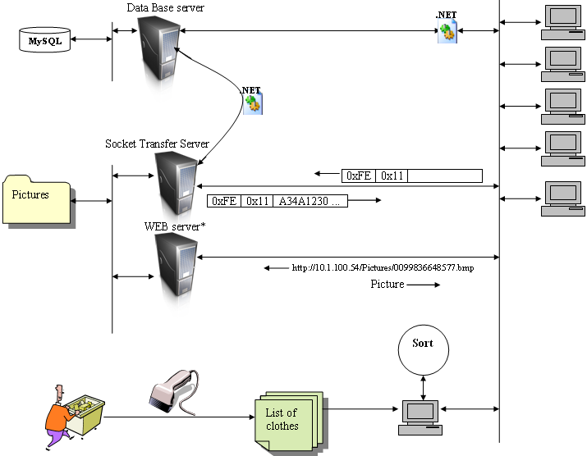

- Conclusions

- References

      - http://en.wikipedia.org/wiki/Database#Types
      - http://en.wikipedia.org/wiki/Relational_database
      - http://en.wikipedia.org/wiki/List_of_relational_database_management_systems
      - FUNDAMENTALS OF DATABASE SYSTEMS, Ramez Elmasri, Shamkant B. N avathe [49 – 83 p., 3 – 48 p.]
      - http://en.wikipedia.org/wiki/Iterative_and_incremental_development
      - http://en.wikipedia.org/wiki/Berkeley_sockets
      - http://www.gnokii.org/

- Appendixes

  - Appendix A: General Socket Protocol Specification

Table 12.1: General protocol specification
Start Command [0xFE] | Command type [0x11 – 0x90] | Value
1 byte | 1 byte | 4 or 24 bytes

Table 12.2: Protocol description
Command Ranges | Command Types | Description
General commands | 0x11 | Get clothes from particular scanner number
General commands | 0x12 | Get bin number from particular tag
General commands | 0x13 | …
General commands | 0x14 | …
General commands | … | …
General commands | 0x70 | Create new file
General commands | 0x71 | Flush existing file
General commands | 0x72 | Remove file
General commands | …
General commands | 0x77 | File transferring
General commands | 0x90 | …
Reserved commands | 0x00 | …
Reserved commands | 0x01 | …
Reserved commands | … | …
Reserved commands | 0x91 | …
Reserved commands | … | …
Reserved commands | 0xFE | Start command, definition of protocol. Other protocols can start with other reserved commands (here just idea)
Reserved commands | 0xFF | …

Command 0x11 – get tag IDs list from particular reader (scanner)

Example: Get clothes from particular scanner number
Method: char[]:= getClothes(scannerNumber)

Table 12.3: Command packet (from client to server)
 | Protocol type | Command type | Value
Value | 0xFE | 0x11 | -
Bytes | 1 | 1 | 4

Table 12.4: Command packet (from server to client)
 | Protocol type | Command type | Number  of values | Value | Value | Value
Value | 0xFE | 0x11 | - | * | * | -
Bytes | 1 | 1 | 4 | 24 | 24 | ...

Command 0x12 – get bin number from particular tag ID

Example 2: Get bin number from particular tag
Method: int:=getBin(tagID)

Table 12.5: Command packet (from client to server)
 | Protocol type | Command type | Value
Value | 0xFE | 0x12 | *
Bytes | 1 | 1 | 24

Table 12.6: Command packet (from server to client)
 | Protocol type | Command type | Value
Value | 0xFE | 0x12 | -
Bytes | 1 | 1 | 4

Notes: * Tag ID format example

Command 0x77 – File transferring

Table 12.7: 0x70 - Create new file
 | Protocol type | Command  type | Command type | Size | Data | Checksum
Bytes | 1 | 1 | 2 | 4 | 1012 | 4
Table 12.8: Example
 | Protocol type | Command  type | Command type | Size | Data | Checksum
Value | 0xFE | 0x77 | 0x70 | 21 | “C:\\hereMyNewFile.bmp” | -

Table 12.9: 0x71 - Flush existing file
 | Protocol type | Command type | Command type | Size | Data | Checksum
Bytes | 1 | 1 | 2 | 4 | 1012 | 4
Table 12.10: Example
 | Protocol type | Command type | Command type | Size | Data | Checksum
Value | 0xFE | 0x77 | 0x71 | 1011 | “C:\\hereMyNewFile.bmp” | -

Table 12.11: 0x72 - Remove file
 | Protocol type | Command type | Command type | Size | Data | Checksum
Bytes | 1 | 1 | 2 | 4 | 1012 | 4
Table 12.12: Example
 | Protocol type | Command type | Command type | Size | Data | Checksum
Value | 0xFE | 0x77 | 0x72 | 21 | “C:\\hereMyNewFile.bmp” | -

  - Appendix B : Data Base UML class diagram

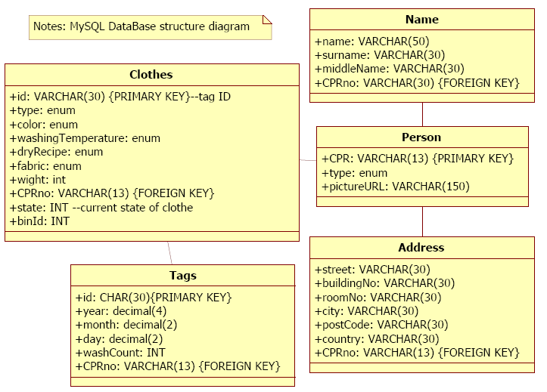

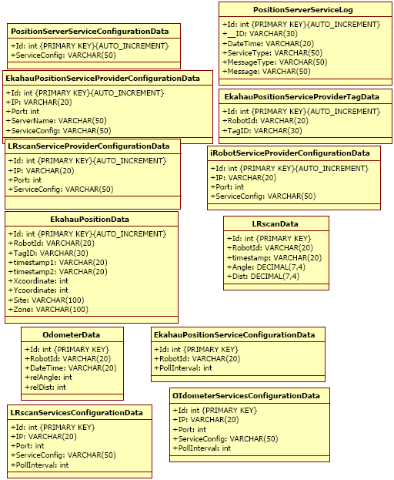
Figure 12.1: Laundry data base class diagram

